28.To design DFA transition diagram of even c’s in automata.

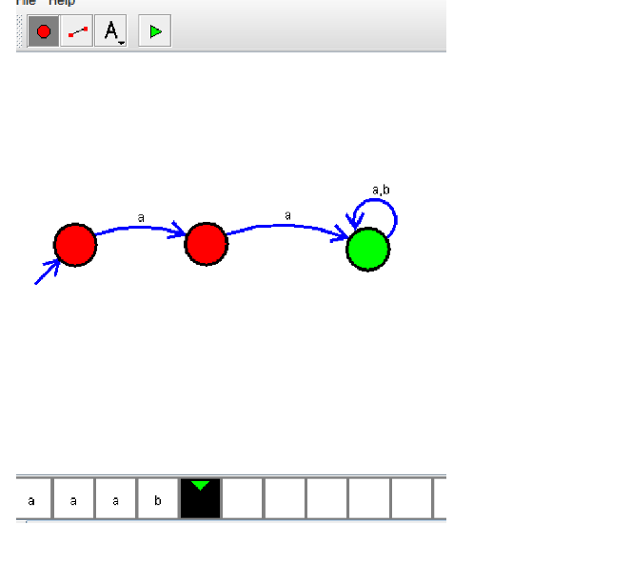

**Result:** Thus designing DFA of even c’s is done and verified by giving sample inputs of even number of c’s